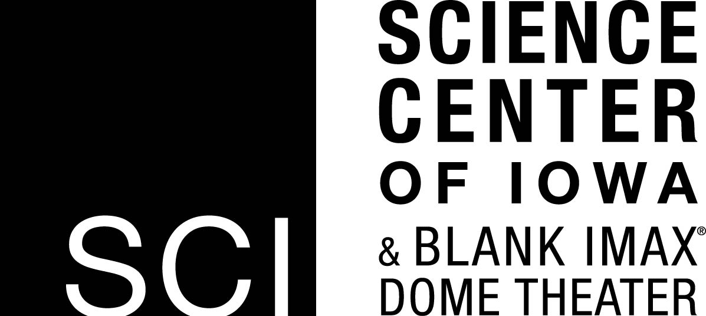
Portal to the Public Workshop Evaluation

Name _______________________________________________________________________________
Department __________________________________________________________________________

- What did you find most useful about the workshop? Why?

- Did this training build on any prior knowledge you had? If yes, what was it and where were you trained?

- If you could have spent more time on one thing in the workshop, what would it have been and why?

- How could the Science Center of Iowa improve the Portal to the Public workshop?

- As part of this training, you are required to visit SCI summer camps as a guest expert. Would you be interested in being involved at SCI beyond that? If so, what would you be interested in doing?

- How well did we do in each of the following areas? Please provide additional comments, if desired.

Needs
Improvement Excellent Comments
Overall organization and structure 1 2 3 4 5

Overall workshop content 1 2 3 4 5

Materials and resources provided 1 2 3 4 5

Length of workshop 1 2 3 4 5

Opportunities to interact with colleagues 1 2 3 4 5

Usefulness of workshop to your future 1 2 3 4 5
work

Workshop instructors 1 2 3 4 5

Overall effectiveness of workshop 1 2 3 4 5

- Do you have any additional thoughts you would like to share with us?

Please return your completed form to the workshop facilitator.
Thank you!

